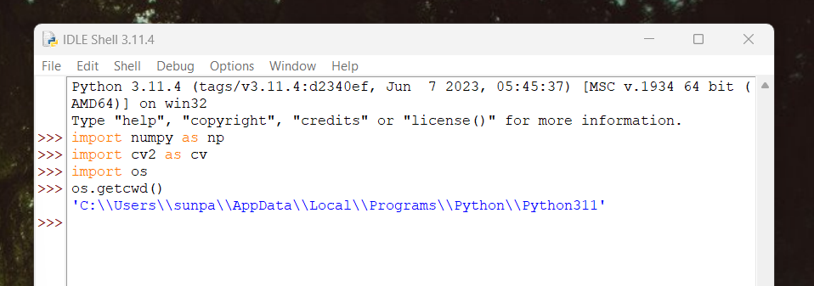

Importing libraries

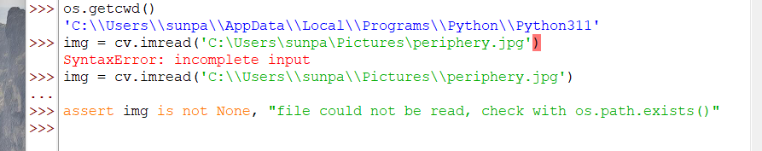

Re entered line using escaped backslashes, python allows for escaped backslashes on windows as well as forward slashes

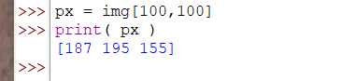

Pixel 100 100 is read

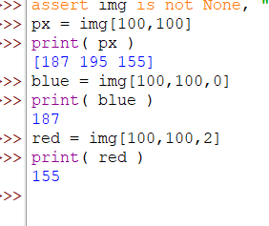

Printing colors from third dimension in the array

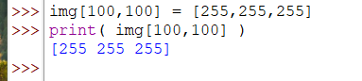

Pixel modification

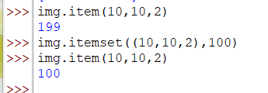

Alternative pixel access and mutate

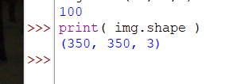

Img.shape



Img.size

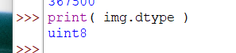

Image datatype

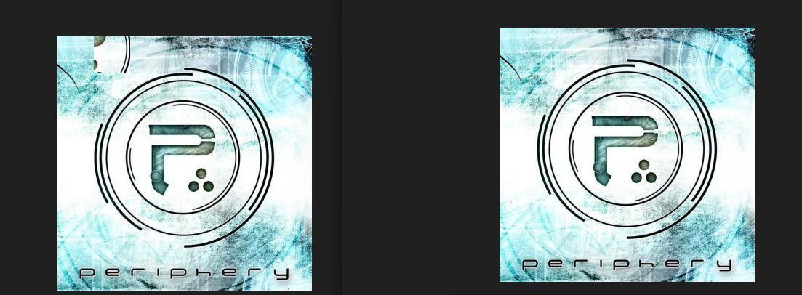

Image before and after

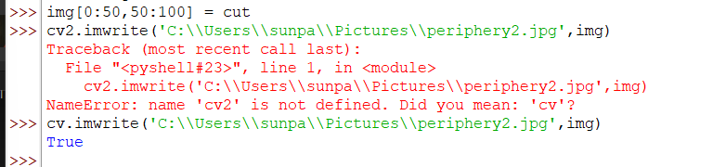

Images are saved using imwrite( path , img )



Merging and splitting color channels

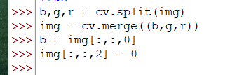

Alternative color channel access and modification

Cv split is a costly operation, use numpy indexing

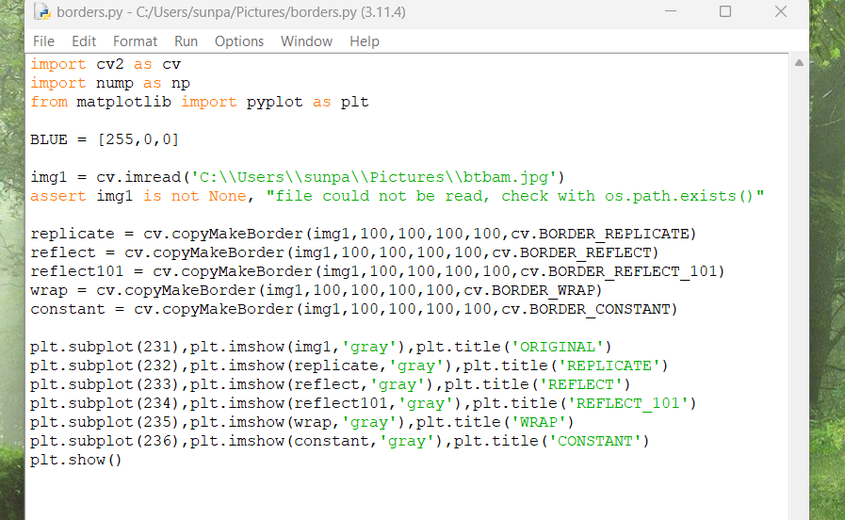

Python file to mess with borders of image

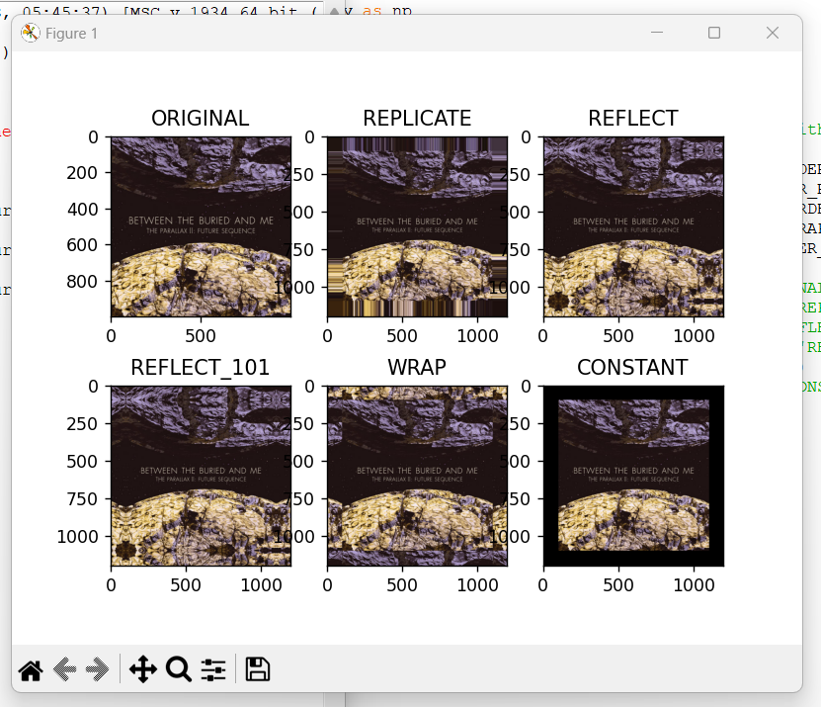

Output, not sure why it is yellow now?

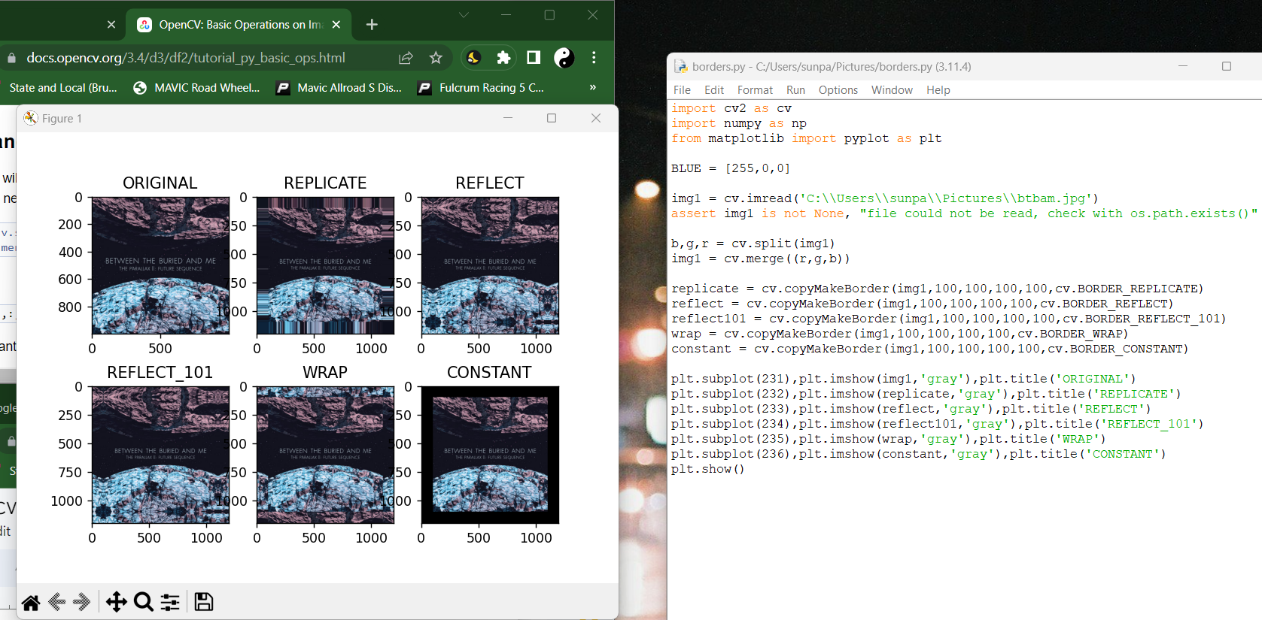

Used cv split and swapped red and blue in the merge and now the colors are correct